Goal for Improvement
What are we trying to accomplish?

Measures
How will we track achievement of our goal?
Ideas  What can we test to achieve this goal? | 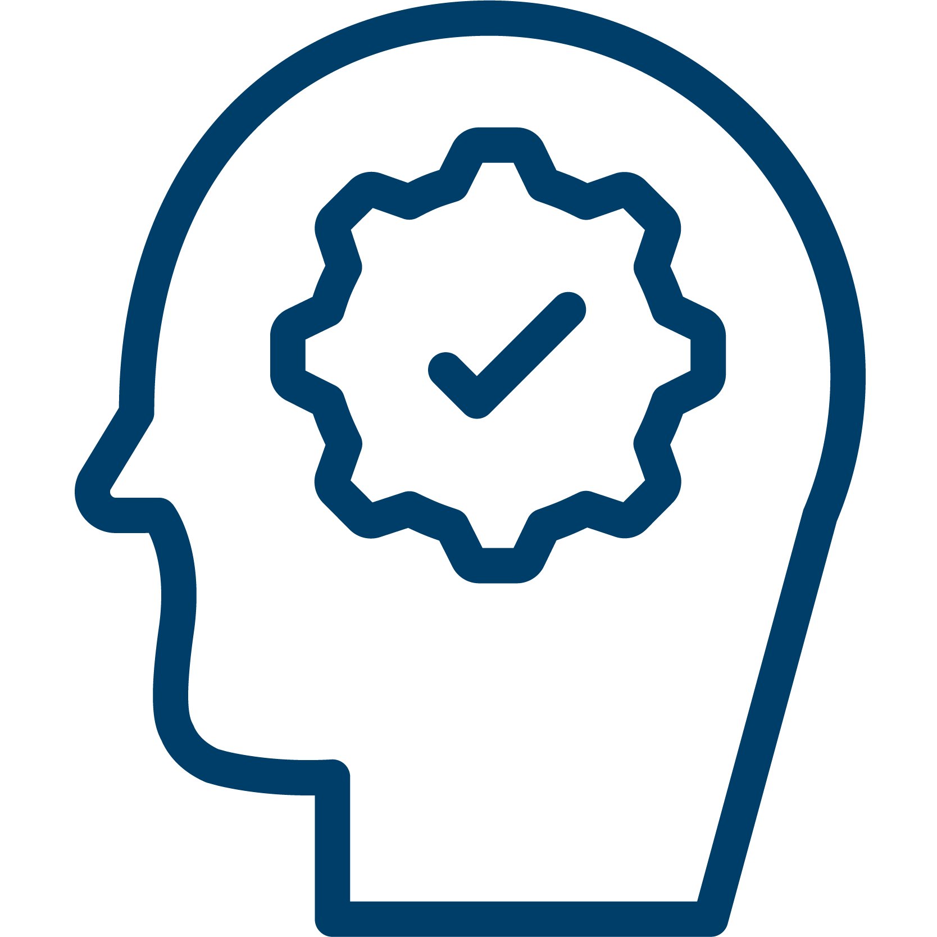  Plan  How and who? |   Do  Did we do it? | 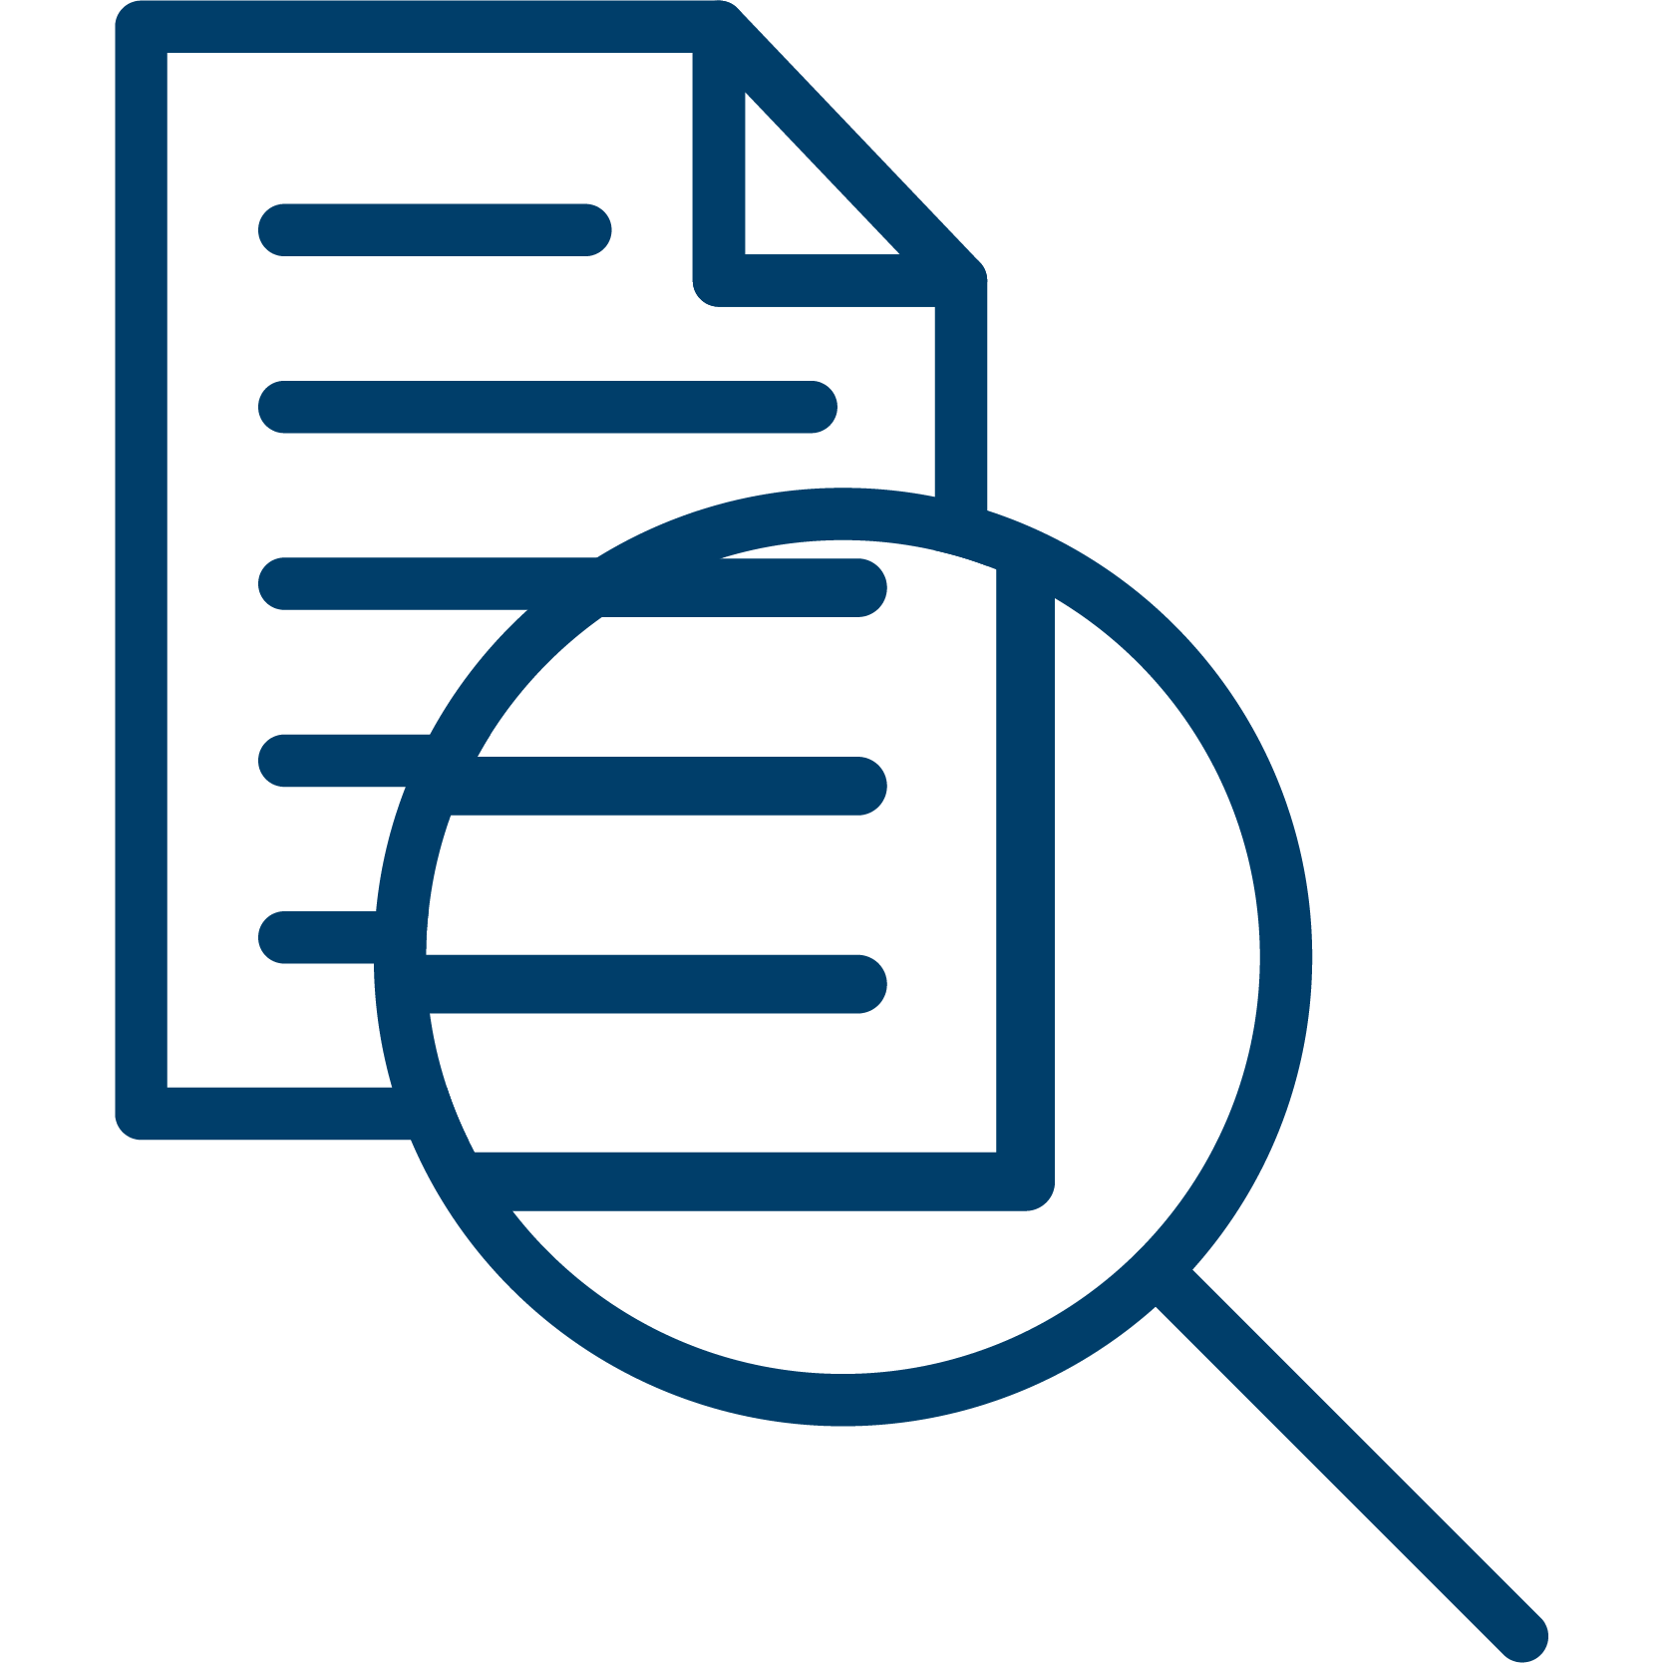  Study  What happened? | 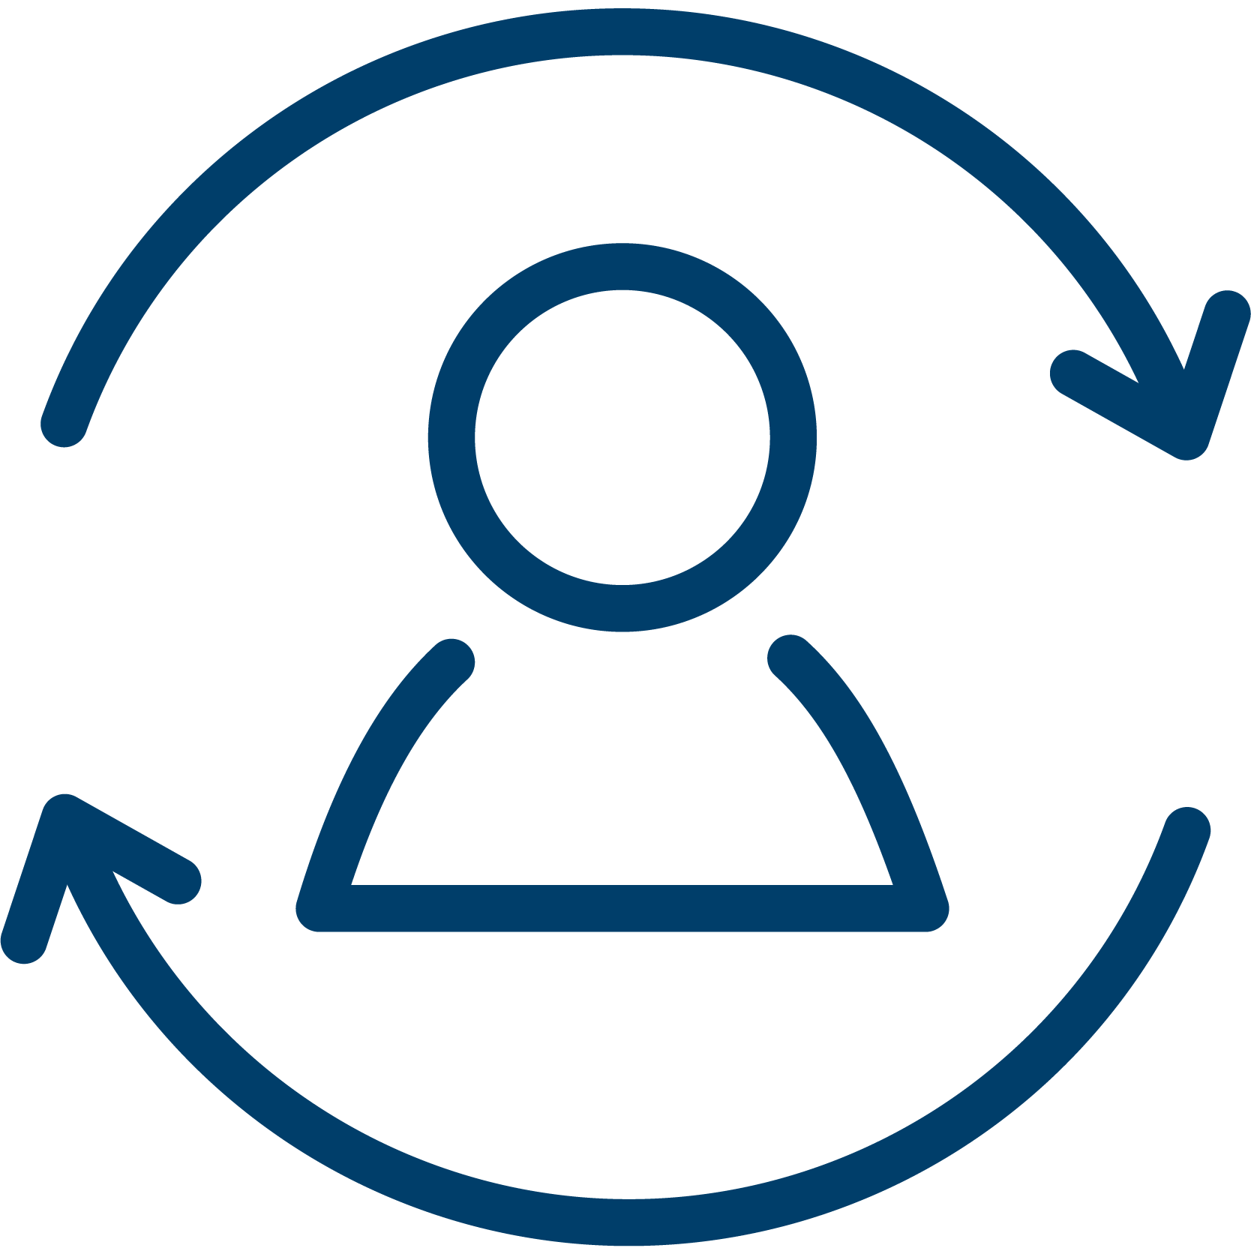  Act  What is our next?

