Team Health Check
The team health check (THC) is a great way to start a quality improvement (QI) exercise. The survey can be used to help identify any problems or concerns about practice systems. Results from the THC can carry forward to multiple Plan-Do-Study-Act cycles in the ‘Model for Improvement’ methodology.
Some steps to undertake:
- Include the “Team Health Check” in two practice meetings –
first to introduce the THC and later to discuss results
A goal is more likely to be attainable
if it is developed by the team in collaboration.

- When will you meet? Who will attend? Who will talk to the topic, administer the tool, explain about anonymity, etc?
- How will completed surveys be submitted confidentially?
- What is people don’t want to go ahead with the survey?
- Who will collate and circulate the survey results?
- Think about how the results might improve communication between clinicians, involve staff in goal setting, etc.
- What could you do to improve team culture? Acknowledgements, competitions, movie nights, book club, walking group, inter-office newsletter, suggestions box, whole-of-team meetings?
- Look at the survey results in relation to QI activities such as proactive diabetes care. For instance, before developing a strategy for diabetes risk screening, what can the THC tell you about who to involve, how to approach these people and how to manage their attitude, time and work load? How does the TCH help you plan communication pathways, record keeping, feedback and evaluation of QI activities?
The Model for Improvement Method:
- Agree on a common ‘stretch’ goal
- Break this into short-term SMART goals
- Introduce change in small manageable chunks
- Break activities into short tests that
- can be measured
- then adopted, or dumped
- are peer to peer
- are adaptable.
with acknowledgement to: Australian Primary Care Collaboratives Program

Practice name: [Add your practice name here]
 | Goals What are we trying to accomplish?
- Improve team communication and culture
- Encourage greater participation of the whole practice team in Quality Improvement activities.
 | Measures How will we know that a change is an improvement?
- Number of occasions on which a Team Health Check (THC) is conducted; aiming for annual. Number of persons completing the THC survey on each occasion.
- Aggregated survey results, as an indicator of improved team communication and culture.
 | Ideas What can we test to achieve the goal?
- Use the THC to identify any problems or concerns which may impede participation of the whole team in QI activities.
- Use the THC to inform management of issues within and between the roles of staff, clinicians and management.
- Use THC results to foster more collegiate / joint / social activities
See sample PDSA over page – adapt to suit

PLAN DO STUDY ACT
See sample PDSA below – Please adapt to suit your needs
 | Plan What, who, when, where, predictions and data to be collected
- Practice Manager and/or lead GP will introduce the topic of team culture at next practice meeting on (date) and invite all members of the practice to anonymously complete the THC form by (date)
- PM will collate, deidentify and aggregate the results.
- Prediction: We are hoping to achieve 75% participation; we are hoping to confirm a healthy team culture in our practice
 | Do Was the plan executed? Any unexpected events or problems?
- As above. Persons (names) who were absent will be followed up by (name).
- The idea was received (enthusiastically/reluctantly) and the response was to (participate/not).
- Surveys (were/were not) completed anonymously and put in the box.
- Results (were/were not) collated in the spread sheet.
 | Study Record, analyse and reflect on the results
- This (was/ not) a successful exercise in involving the team in the principle of QI to encourage participation in QII activities
- There was a willingness to improve team culture.
- (number) surveys were completed.
- The overall team health rating was (great / fair / disappointing)
- Some social activities were suggested and have already taken place.
- Some new communication strategies have already been put in place.
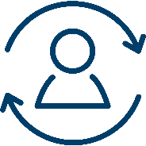 | Act What will we take forward; what is the next step or cycle?
- Present the THC survey results at the next practice meeting and share with people not attending that meeting.
- Discuss the level of participation, issues highlighted and management decisions arising.
- Consider further activities – social and or communication strategies.
- Table a proposal to repeat the THC annually.
- Develop a practice policy for conducting THC annually and write this into the PPM.
- Put a reminder in the calendar for next (date), when the PM will hand out THC, to be collated and presented at the (date) practice meeting.

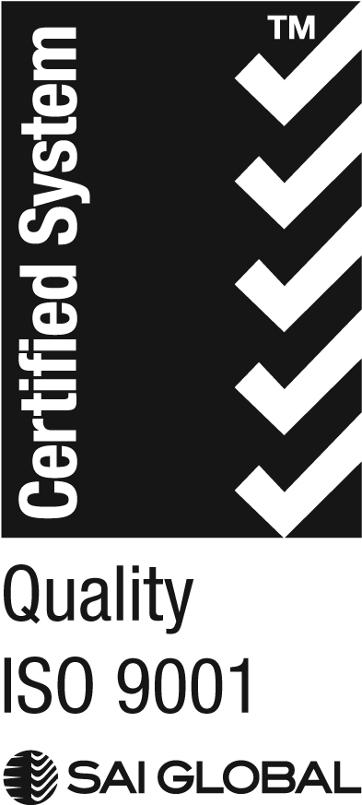
We acknowledge the peoples of the Kulin nation as the Traditional Owners of the land on which our work in the community takes place. We pay our respects to their Elders past and present.

