Primary Care - RACH Coordination Toolkit

A resource to support partnerships between Residential Aged Care Homes and Primary Care

Acknowledgement

This toolkit has been developed by the National MyMedicare PHN Implementation Program with input from PHNs throughout Australia. We acknowledge that some resources used or referenced within this toolkit are from organisations including the Department of Health and Aged Care, Services Australia, Royal Australian College of General Practitioners (RACGP); ACCPA, HNECC PHN, NBMPHN and Healthy North Coast PHN. These organisations retain copyright over their original work. Referencing of material is provided throughout.

Disclaimer and Recognition

While the Australian Government Department of Health and Aged Care has contributed to the funding of this material, the information contained in it does not necessarily reflect the views of the Australian Government and is not advice that is provided, or information that is endorsed, by the Australian Government. The Australian Government is not responsible in negligence or otherwise for any injury, loss or damage arising from the use of or reliance on the information provided herein.

The information in this toolkit does not constitute medical advice and the PHN Cooperative accepts no responsibility for the way in which information in this toolkit is interpreted or used. Unless otherwise indicated, material in this booklet is owned by the PHN Cooperative. You are free to copy and communicate the work in its current form, as long as you attribute the PHN Cooperative as the source of the copyright material.

Due to constant developments in research and health guidelines, the information in this document will need to be updated regularly. Please contact the PHN Cooperative if you have any feedback regarding the content of this document.




Primary Care & Residential Aged Care Coordination Toolkit

For general practice care in Residential Aged Care Homes

Navigating this Toolkit
Introduction & Background
- Purpose of the Toolkit
- Toolkit Overview
- Why spend time on Coordination?
- Partnership Continuum

Improving Quality
- Improving Patient Access to Care

Improving Connections
- Connecting with families and guardians
- Connecting Residents with General Practitioners
- Connecting the Health System

Safety in Action
- Emergency Management, Incident Management & After Hours Care Access

Appendix 1 - Orientation Information for GPs in RACHs
Template – Orientation Information for General Practitioners

Appendix 2 – General Practice and RACH Collaboration Action Plan
Primary Care and RACH Collaboration Checklist
Primary Care and RACH Collaboration Action Plan
General Practice and RACH Quality Improvement Actions

Appendix 3 – Coordination Meeting Proforma

Appendix 4 – Mapping of RACGP Standards & Strengthened Aged Care Standards

Purpose of this Toolkit

The aim of the Primary Care – RACH Coordination Toolkit is to provide tools and tips for improving coordination between Residential Aged Care Homes (RACHs) and General Practices. Through collaborative effort, stronger partnerships between RACHs and GPs will support improved planning and delivery of primary care services in the RACH setting for residents.

The resource was developed to complement the General Practice in Aged Care Incentive Program which focuses on enhancing continuity and quality of care by shifting from volume-based care towards structured, regular care planning, supporting a preventative care model. This toolkit is intended for both staff in RACHs and Primary Care.

This toolkit has been developed by Primary Health Networks through the National PHN MyMedicare Implementation Program.

Background
Having all health professionals, the resident, and the family ‘all on the same page’ regarding care goals is important.
The RACGP describes collaboration and multidisciplinary team-based care as essential for the optimal care of older people, particularly those in residential aged care facilities (RACFs) and in the community^.
In residential aged care, the GP provides medical oversight of the resident. In some organisations, Nurse Practitioners may also oversee a resident’s care. Collaboration across the care team has benefits for patients, the team and its members and the organisation. Many different care providers can make up a resident’s care team and not all are co-located within the RACH.
Through a series of steps, all members of the care team can improve their experience in delivering care, leading to improved care outcomes for the resident.
^Source: RACGP - Supporting sustainable GP-led care for older people Source: RACGP - RACGP - Supporting sustainable GP-led care for older people

Why spend time improving coordination?
- Establishing effective partnerships in healthcare is not just a good idea, it’s essential. These partnerships play a significant role in enhancing the overall experience for patients. Imagine healthcare relationships built on principles like dignity, respect, shared information, and active participation. Partnerships should exist between care providers such as RACHs and General Practices, as well as with the resident and their families.
- Improving coordination between RACH and general practice enables both parties to understand and respond to the health care and other needs of residents and improves access to quality primary care for residents.
- Well understood arrangement facilitate better experiences for providers and residents. They can also support regular engagement and communication between health care professionals which can reduce errors and incidents that can lead to the need for urgent and/or after-hours care. Agreed provider arrangements can also lead to improved palliative and end of life care.
- Good care is less likely when communication is fragmented.
- Collaboration and great working partnerships make excellent care possible!
- This is a great blog article about the importance of working in partnership if you would like to read further on this topic: What Is Partnership Working In Health And Social Care? - Care Learning



The Partnership Continuum
The partnership continuum can help RACHs and care providers to reflect on the level of engagement among the care team. This can also be considered as a measure of the ‘health’ or maturity of the partnership.

Progressively moving towards an integrated partnership is encouraged. Tools contained in this resource have been designed to support better integration and collaboration among the care team. GPs and RACHs are encouraged to use tools including the orientation toolkit (appendix 1) and the collaboration action plan (appendix 2) to improve coordination of care elements including visiting arrangements, immunisation processes and areas of clinical governance.

This is a great blog article about the importance of working in partnership if you would like to read further on this topic: What is Partnership Working in Health and Social Care? – Care Learning

Improving Quality of Care
Common barriers to quality care and friction points
Collaborative care between the Residential Aged Care Home (RACH) and General Practices can be a challenge, often influenced by key friction points that create frustration on either side. In the coming pages, this toolkit will consider some actions that can facilitate better collaboration, access to quality primary care for aged care residents and improved partnerships.
Improvements made at the system level, the organisation level and the clinician level go a long way in improving the care experience for the resident, family, clinical and care team. Whilst there is still much to do at all these levels, progress is being made and is explored in the following pages.

Making progress! Governments and organisations have been prioritising efforts to improve quality of care for residents in RACHs. The following table displays some of the progress against known friction points in the aged care system. These friction points informed recommendations from the RACGP in supporting sustainable GP-led care for older persons.
Improvements required | Solutions in place | More Information
Health System led Improvements
Blended funding models^ that promote planned and continuous care. | General Practice in Aged Care Incentive | General Practice in Aged Care Incentive | Australian Government Department of Health and Aged Care
Voluntary patient enrolment^ that promotes greater connection between patients with their GP. | MyMedicare program | MyMedicare | Australian Government Department of Health and Aged Care
Investments in workforce capacity and capability for clinical and non-clinical staff. | Pharmacists in aged care  Help to access telehealth​  Help to develop after-hours plans | Aged care on-site pharmacist  Supporting access to primary care for aged care residents
Organisation-led improvements
Digital systems that connect GP practices with RACH systems, hospitals and pharmacy (interoperability) | Infrastructure and technology advancements to promote and incentivise system connection are in planning phases.  Connecting My Aged Care with My Health Record. | Aged Care Data and Digital Strategy | Australian Government Department of Health and Aged Care  ​My Aged Care support plans now available in My Health Record
Telehealth access and telehealth capability within RACHs | Infrastructure | https://resiagedcaretelehealth.training/
After Hours Support | A guide for residential aged care homes | https://nwmphn.org.au/for-primary-care/clinical-support/after-hours-health-care-toolkit-for-residential-aged-care-homes/
GP involvement in clinical governance and clinical oversight | Changes to accreditation in standards | Part 3: Clinical Governance | Insights into the RACGP Standards 6th edition

Actions at the RACH to Improve Collaboration
Administrative:

Consistent and agreed ways of working together supports positive working relationships. An MOU or Partnership Agreement or another document that confirms the agreed ways of working together is recommended. This should include an after-hours plan for primary care matters on emergent health issues for residents.

Allocation of RACH staff that are responsible to coordinating visits with the General Practice, enable a staff member to be on hand on the GP's arrival as an onsite contact point to assist with logistics such as finding records and patients.

Does the RACH have - or is it possible to create - a dedicated, safe and private environment such as a consultation room for the GP? This protects residents’ privacy and supports the delivery of quality care.

Clinical:
- Utilise the ISBAR clinical handover tool (link here) as a standardised approach to support best practice clinical handover – this will assist to improve communication between care staff.
- Access to an onsite pharmacist is beneficial for GPs, RACH staff and residents. Aged care on-site pharmacist
- Telehealth also provides an opportunity for collaboration or coordination conversations if face to face is a challenge. The PHN Cooperative has developed a national online training for RACH to enhance telehealth capabilities. https://resiagedcaretelehealth.training/
- The Aged Care Transfer Summary is a digital solution using My Health Record. It provides crucial health information about a person living in RACH. This information supports the transition of the resident from an aged care setting to acute hospital care when needed. ​



Actions at the General Practice to Improve Collaboration

Administrative:
- Consistent and agreed ways of working together supports positive working relationships. An MOU or Partnership Agreement or another document that confirms the agreed ways of working together is recommended. This should include an after-hours plan for primary care matters on emergent health issues for residents.
- Provide the RACH a contact point at the General Practice for staff to contact to discuss visit arrangements and logistics e.g., practice manager, admin team member or practice nurse.
- Provide RACH staff/ facility with a schedule of visits with identified patients ahead of time to allow logistics planning by RACH before the GP visit.
- Utilise GPACI MBS items such as the Care Coordination items that assist in supporting planned and coordinated care with the multi-disciplinary team included.

Clinical:
- Utilise the ISBAR clinical handover tool (link here) as a standardised approach and best practice – this will assist in improved coordination between RACH and General Practice at the individual patient level.
- Agree on a triage framework with the RACH to enable all parties to be on the same page when incidents such as a patient fall occur. It is important that RACHs and General Practice know how to manage these instances both in-hours and after-hours.
- Discuss immunisation plans with the RACH – including plans for vaccine storage and access.

- Utilise My Health Record (MHR) - Aged Care Support Plans are now integrated into MHR providing the care team with more comprehensive information. This enables quicker and better-informed decisions regarding their treatment.

Tools & Templates
Appendix 1: General Practice and RACH Collaboration Action Plan
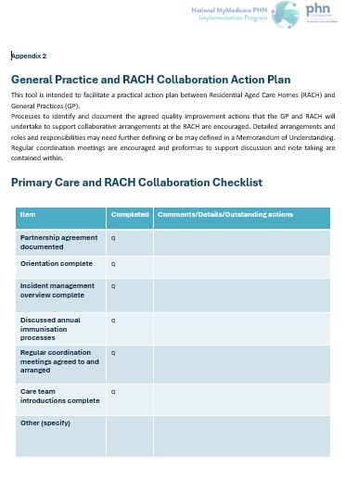
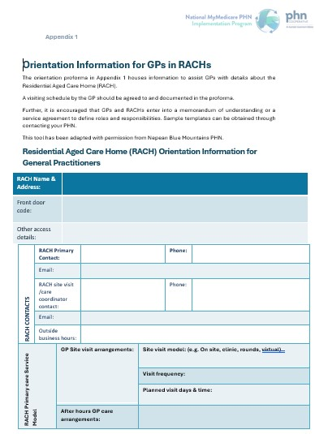
Appendix 2: Orientation for GPs with RACHs
See appendix documents for this Toolkit.

MOU or Partnership Agreement
Speak with your PHN
PHN link to SharePoint resource/template: https://healthgov.sharepoint.com/:f:/r/sites/secretariatcommittee/phn/MyMedicare PHN Implementation Program/GPACI/RACH MOU?csf=1&web=1&e=5RCU8E
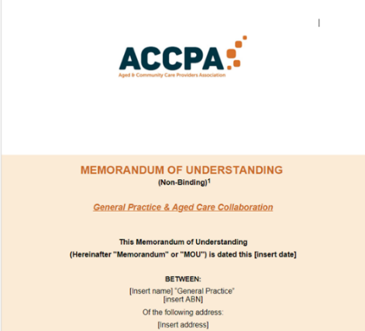

Toolkit for Clinical Handover
https://www.safetyandquality.gov.au/our-work/communicating-safety/clinical-handover/implementation-toolkit-clinical-handover-improvement
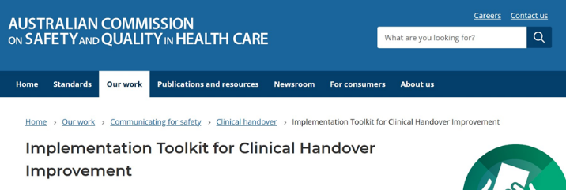

Connecting with Families and Guardians
Involving families and guardians in care regimes can help to identify what matters when the resident’s needs change and improves experience for all involved. Involving a resident's family or guardian in their care decisions while at a RACH assists in supporting carer expectations.
The ELDAC website has some information and resources to help support the care team to engage with families about end-of-life care. Building on initial conversations over time helps develop trust and relationships for these sensitive conversations.
Talking with Families - Our Products- ELDAC
Even if the resident is not facing end-of-life healthcare decisions, partnering with residents' families greatly improves health outcomes. Ensuring a partnership between the resident, their family and the RACH assists in achieving Standard 1 of the Strengthened Aged Care Quality Standards.



Connecting residents and GPs
The Australian Government has introduced a program to foster better connections between a patient and their GP. This is known as voluntary patient enrolment and enables patients to choose a GP and Practice as their usual care provider. This program is called MyMedicare.

Information about MyMedicare
MyMedicare assists to formalise relationships between patients and their GP and care team. Patients can choose who they nominate as their preferred GP. The program is voluntary. The resources below can help explain the benefits and what it means for them.
- Patient Brochures mymedicare-dl-brochure.pdf (health.gov.au)

- Patient Videos Introducing MyMedicare | Australian Government Department of Health and Aged Care
Registering in MyMedicare | Australian Government Department of Health and Aged Care

- MyMedicare resources for Health Professionals
Resources for MyMedicare general practices and healthcare providers | Australian Government Department of Health and Aged Care

In addition to MyMedicare, the Australian Government launched a new incentive program in 2024 specifically for GPs to better support residents living in aged care homes.

Information about the General Practice in Aged Care Incentive

The General Practice in Aged Care Incentive has been created as a next step in fostering improved connections between GPs and patients, specifically for people living in RACHs. The General Practice in Aged Care Incentive promotes planned and quality care for residents through offering incentives to GPs to carry out regular and planned care with residents. Additionally, all consultations need to take place at the RACH (or via telehealth (if in MMM 4-7 areas). More information can be found via the links below:

- For GPs & Practices: GPs and practices | Australian Government Department of Health and Aged Care

- For residents & families: Aged care residents, their families and carers | Australian Government Department of Health and Aged Care

- For Residential aged care home staff: Residential aged care providers | Australian Government Department of Health and Aged Care

- Care plan contribution template

GP Champion Videos – MyMedicare and General Practice in Aged Care Incentive

- Video 1 https://youtu.be/tFNUhZZpy9o
- Video 2 https://youtu.be/jlFYDB5D4T8
- Video 3 https://youtu.be/xcPMx2jaRq8

Other useful links and information:
- MyMedicare | NWMPHN

Connecting care teams
Promoting collaboration for care teams:
Five principles to help enhance team effectiveness include^:
    - shared purpose and goals
    - clear roles and responsibility
    - mutual trust
    - effective communication
    - measuring process and outcomes of team function
The collaboration action plan (Appendix 2) and other templates housed in this toolkit have been formed to guide care teams to have these conversations.
  - Case conferences are a productive way of coordinating care, and can engage the whole multidisciplinary team, resident and their family. Planning a case conference for a resident in a RACH allows collaboration to occur at the individual patient level, further adding to quality and access to primary care and improving health outcomes. Detail on MBS items available to support case conferencing can be found here.
  - Optimising care planning items – With the launch of the General Practice in Aged Care Incentive program together with the array of existing Medicare benefits items, GPs and care teams can leverage incentives to plan and coordinate care for residents. For information on care planning items click here or speak with your PHN.
^ Collaboration-and-multidisciplinary-team-based-car.aspx

The General Practice in Aged Care Incentive can support better primary care engagement with greater emphasis placed on continuity and planned care. Through successful collaboration, and strong partnerships between RACHs and general practice, RACHs may be better placed to meet some of the criteria in the Aged Care Quality Standards.


Connecting the Health System

Health Pathways

HealthPathways offers clinicians locally agreed referral information to make the right decisions together with patients, at the point of care.
The pathways are designed primarily for general practice teams, but are also available to specialists, allied health professionals, and other health professionals in your region. The pathways include a large number of specific aged care clinical referral pathways, including fall prevention.
HealthPathways Melbourne

How your local PHN can assist
PHN Role
Primary Health Networks (PHNs) assess the health and aged care needs of their community and commission health services to meet those needs, minimising gaps or duplication. They support health services to connect with each other to improve people’s care and strengthen the primary health care system.
Your local PHN is currently working to:
- improve communication, coordination and integration of primary care services with RACHs, including after-hours
- consider how access and appropriateness of existing primary health care services may be improved for older people, including via telehealth.
- NWMPHN works closely with general practices, mental health, allied health and other primary health care professionals to identify service gaps. Then we collaborate to co-design and fund innovative and effective solutions that make it easier for people to get the care they need.
- with a focus on at-risk members of the community, we are driven by a vision for a primary care system that is person-centred, comprehensive, coordinated, accessible, high quality and safe.

Consider speaking with your local PHN about ways they may be able to support collaboration or coordination of primary care services in the RACH setting.
Contact the Primary Care Quality Improvement team or the Aged Care Capability team on 03 93471188


Safety in Action

Emergency Management
The Aged Care Quality Standards require RACHs to maintain effective risk management systems and practices. These systems ensure RACHs can manage high-impact risks to the care of older people during an emergency. Emergency risk management falls under Standard 3 and Standard 8 of the strengthened aged care standards.
https://www.agedcarequality.gov.au/providers/quality-standards/strengthened-quality-standards#new-strengthened-quality-standards-guidance-tool
If the RACH you work in needs an update to the current Emergency Management Plan, a template can by found here: https://www.safeworkaustralia.gov.au/doc/emergency-plan-template


Incident Management
It is suggested that RACHs ensure that regular general practitioners and other primary care team staff are aware of incident management processes that are in place at the RACH. This is to support prevention of incidents and to enable documentation of incidents should they occur when they are onsite.
Best Practice Guidance can be found here: https://www.agedcarequality.gov.au/sites/default/files/media/effective-ims-guidance-august-2021.pdf
Preventing Incidents:
https://www.agedcarequality.gov.au/for-providers/serious-incident-response-scheme/incident-management-systems/preventing-incidents#residential-care-incident-example


After-Hours Care access
As part of successful collaboration between general practice and RACH, it is necessary to identify options for urgent out of hours clinical care for residents.
Options may include:
- A local/regional GP after-hours arrangement – speak with your local PHN or the visiting GPs
- Medical Deputising Services
National Association for Medical Deputising: https://www.namds.com.au/
- Health Direct may be able to assist after-hours:
Health Direct: https://www.healthdirect.gov.au/after-hours-health-services

Conversations between the General Practice and RACH about after-hours care form part of collaborative actions and are critical for smooth partnerships between general practice and RACHs.

Residential aged care providers should ensure:
- Safety for residents, staff and visiting providers
- To notify all staff and visiting providers if after-hours agreements with service providers change
- All RACH staff are trained in after-hours planning and can quickly locate residents’ after-hours plans

Review cycle for Primary Care - RACH Coordination Toolkit
PHNs have jointly developed this resource through the National PHN MyMedicare Implementation Program, supported by the PHN Cooperative.
Review of the original National PHN MyMedicare branded resource will occur ~6 monthly or as required upon changes to the General Practice in Aged Care Program.
This document is Version 1, published on 20 Mar 2025. The next review of the resource is due Sep 2025.

Printed copies of this resource are uncontrolled and may not contain the most up to date information.
If you have any feedback on this resource, please contact PHNMyMedicare@brisbanenorthphn.org.au

Appendix 1

Orientation Information for GPs in RACHs
The orientation proforma in Appendix 1 houses information to assist GPs with details about the Residential Aged Care Home (RACH).
A visiting schedule by the GP should be agreed to and documented in the proforma.
Further, it is encouraged that GPs and RACHs enter into a memorandum of understanding or a service agreement to define roles and responsibilities. Sample templates can be obtained through contacting your PHN.
This tool has been adapted with permission from Nepean Blue Mountains PHN.

Residential Aged Care Home (RACH) Orientation Information for General Practitioners
RACH Name & Address:
Front door code:
Other access details:
RACH CONTACTS | RACH Primary Contact: |  |  |  | Phone:
RACH CONTACTS | Email:
RACH CONTACTS | RACH site visit /care coordinator contact: |  |  |  | Phone:
RACH CONTACTS | Email:
RACH CONTACTS | Outside business hours:
RACH Primary care Service Model |  | GP Site visit arrangements: |  | Site visit model: (e.g. On site, hybrid, telehealth)
 |  |  |  | Visit frequency:
 |  |  |  | Planned visit days & time:
 |  | After hours GP care arrangements:

Care Capacity | Total RACH Resident Capacity: |  |  | Considerations:
Care Capacity | Total respite bed capacity: |  |  | Dementia Care Unit capacity:
Care Capacity | Number of RN staff on shift (in hours): |  |  | Other:
SOFTWARE | Clinical Software: | Note: GPs may need to have their own login. | Software IT Support
SOFTWARE | eNRMC: | Note: GPs may need to ‘delegate’ their GP registrars to use this software. | eNRMC IT Support:
SOFTWARE | Telehealth platform: | Product: | Details:
SOFTWARE | My Health Record: |  Yes, connected to the RACH’s clinical software |  Not connected
SOFTWARE | Secure Messaging: |  | Not Installed
SOFTWARE |  | Electronic Data Interchange (EDI) code:
Local Health Service Aged care contacts:
Local hospital & urgent care arrangements:
Gerontology:
Palliative Care:
Mental health:
Virtual care:
Local PHN Contact Details:

Members of the Multidisciplinary Team & visiting specialists
Role in Care Team | Name | Phone | Email

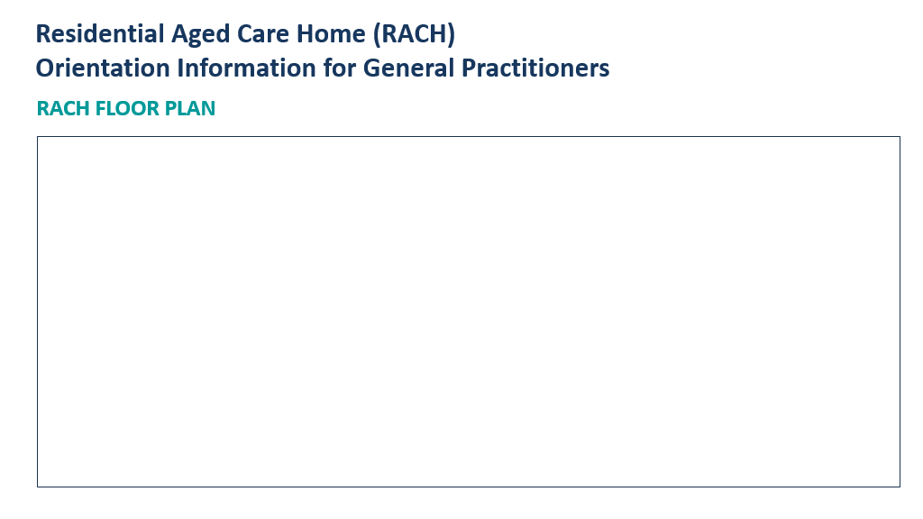

Appendix 2

General Practice and RACH Collaboration Action Plan
This tool is intended to facilitate a practical action plan between Residential Aged Care Homes (RACH) and General Practices (GP).
Processes to identify and document the agreed quality improvement actions that the GP and RACH will undertake to support collaborative arrangements at the RACH are encouraged. Detailed arrangements and roles and responsibilities may need further defining or be may defined in a Memorandum of Understanding. Regular coordination meetings are encouraged and proformas to support discussion and note taking are contained within.

Primary Care and RACH Collaboration Checklist
Item | Completed | Comments/Details/Outstanding actions
Partnership agreement documented | ☐
Orientation complete | ☐
Incident management overview complete | ☐
Discussed annual immunisation processes | ☐
Regular coordination meetings agreed to and arranged | ☐
Care team introductions complete | ☐
Other (specify)

Primary Care and RACH Collaboration Action Plan

Partnership between:

Agreed meeting format:

Meeting Schedule and Frequency of meetings:

Coordinator/Lead:

Representatives & Role:

Partnership Vision:

General Practice and RACH Quality Improvement Actions
Quality improvement Area | Issues & Solutions | Goals/What success looks like | RACH Actions | GP/Practice Actions | Implemented by  (due date)
Administration (includes clinical documentation)
Care access

Medication charts

GP/Practice/RACH Communication
Care planning activities

After hours care
Post hospital follow up

Advance care planning

Other

Appendix 3

Coordination Meeting Proforma
Meeting Date
Time
Venue
Chair
Secretariat
Attendees & Role
Actions from previous meeting

AGENDA ITEMS | Actions
Clinical Items
Administration Items

Appendix 4

DOCUMENT PURPOSE:
The intent of this document is to provide information about the synergies between the General Practice Aged Care Incentive and accreditation standards both in general practice and in the residential aged care setting.
PHNs may work with aged care staff or general practice staff to highlight this alignment to assist in improving working relationships between RACHs and GPs, be a facilitator for discussion and assist to improve engagement and partnerships.
Whilst having patients participating in General Practice in Aged Care Incentive will not automatically meet accreditation standards for RACHs, RACHs and GPs working together to improve access, frequency and improve planned and documented primary care and care plans will assist in meeting Standard 2 and 3 of the aged care standards.
RACGP Standards for General Practices (5th Edition)

Strengthened Aged Care Quality Standards

GP Aged Care Incentive
aligns with...
Strengthened Aged Care Quality Standards
RACGP Standards for General Practice
Practice


MyMedicare and the new General Practice in Aged Care Incentive supports Residential Aged Care Homes to meet several Aged Care Accreditation Standards.
Standard 1 - Consumer Dignity and Choice
Standard 2 - Assessment and Planning
Standard 3 - Personal Care and Clinical Care
MyMedicare and the new General Practice in Aged Care Incentive supports General Practice and aligns with RACGP Standards for General Practices (5th edition)
Core Standard 1 - Communication and patient participation
Core Standard 4 - Health promotion and preventive activities
QI Standard 1 - Quality improvement
GP Standard 1 - Access to care
GP Standard 2 - Comprehensive care

The General Practice in Aged Care Incentive will make it easier for older people living in residential aged care homes to receive regular visits and care planning services from their responsible GP and practice. This supports improved continuity of care, improved primary care outcomes, and aims to reduce avoidable hospitalisations.



RACGP Standards for General Practices
This Core Standard determines that communication must be patient centred. This means that the practice team considers the patient’s values, needs and preferences, and gives the patient time to provide input and participate actively in decisions regarding their healthcare. This standard also seeks that patients must be provided with the appropriate information they need to manage their condition.
General Practice in Aged Care Incentive is also a patient focused incentive program, focused on ensuring that patients engage with their preferred Practice and GP and register to be a part of the MyMedicare program.
Particularly important for residents living in an aged care home, the practice must also consider the communication needs of carers and other relevant parties.
Core Standard 1 - Communication and patient participation
QI Standard 1 - Quality improvement
Core Standard 4 - Health promotion and preventive activities

This Standard encourages quality improvement so that the practice can identify opportunities to make changes that will improve patient safety and care.
Quality improvement can be achieved in a number of ways, one of which is the regular review of your practice’s structures, systems and clinical care.
The structure of General Practice in Aged Care Incentive lends itself to QI activities, it provides an opportunity for a practice to review the care provided to clients who live in a RACH, and plan for improved care outcomes. Key care planning items such as medication review enhance activities that improve patient safety and care, particularly being patient centred in a care approach with considerations as people age such as poly pharmacy and changing medication needs.

General Practice in Aged Care Incentive allows for a holistic approach to care that encourages a practice to consider and respond to each patient’s individual circumstances when providing health promotion, preventive care, early detection and intervention. This is in line with Core Standard 4.
General Practice in Aged Care Incentive encourages a practice to work with the RACH to provide comprehensive and anticipatory care for residents in Aged Care rather than the provision of care that responds to emergent or acute health issues. Approaching care in a planned and regular manner enables a focus on preventive activities.
This standard also recommends the GP and health team to consider heritage (e.g. does the patient identify as being of Aboriginal or Torres Strait Islander origin?), medical or social conditions, and financial circumstances.





GP ACI provides a prompt for the General Practice to consider a review of historical billing practices for Residential Aged Care Home patients and use the guide to develop a quick PDSA (Plan – Do – Study – Act) to identify any improvements you could make to billing and care practices.
Quality Improvement and link
GP ACI to PDSA
GP Standard 2 - Comprehensive Care
GP Standard 1 - Access to care
This Standard includes criteria that relate to providing access to comprehensive care in a general practice context. They include the:
  - triage of patients so that the most appropriate care is provided
  - ability for the practice to conduct home and other visits
  - ability for the practice to provide after-hours care.
These aspects are all important to GP ACI, the incentive program seeks for a coordinated approach to primary care for residents in aged care.
Additionally, all consultations need to take place at the RACH or via telehealth (if in MMM 4-7 areas).
There is also provision for after-hours MBS items for GP ACI consultations.
This standard seeks that the GP and practice provide comprehensive care. This includes the coordinated delivery of the total health care required or requested by a patient.
The scope spans prevention, health promotion, early intervention for those at risk, and the management of acute, chronic and complex conditions within the practice population whether in the home, practice, health service, outreach clinic, hospital or community.
By providing comprehensive care for aged care residents through the use of the GP Aged Care Incentive (GP ACI) it contributes to the overall goal of GP ACI to reduce hospital admissions for residents of aged care.

RACGP Standards for General Practices
RACGP Standards for General Practices
GP Standard 1 - Access to care
Quality Improvement and link
GP ACI to PDSA
GP Standard 2 - Comprehensive Care
This Standard includes criteria that relate to providing access to comprehensive care in a general practice context. They include the:
  - triage of patients so that the most appropriate care is provided
  - ability for the practice to conduct home and other visits
  - ability for the practice to provide after-hours care.
These aspects are all important to General Practice in Aged Care Incentive, the incentive program seeks for a coordinated approach to primary care for residents in aged care.
Additionally, all consultations need to take place at the RACH or via telehealth (if in MMM 4-7 areas).
There is also provision for after-hours MBS items for General Practice in Aged Care Incentive consultations.
This standard seeks that the GP and practice provide comprehensive care. This includes the coordinated delivery of the total health care required or requested by a patient.
The scope spans prevention, health promotion, early intervention for those at risk, and the management of acute, chronic and complex conditions within the practice population whether in the home, practice, health service, outreach clinic, hospital or community.
By providing comprehensive care for aged care residents through the use of the General Practice in Aged Care Incentive it contributes to the overall goal of General Practice in Aged Care Incentive to reduce hospital admissions for residents of aged care.
General Practice in Aged Care Incentive provides a prompt for the General Practice to consider a review of historical billing practices for Residential Aged Care Home patients and use the guide to develop a quick PDSA (Plan – Do – Study – Act) to identify any improvements you could make to billing and care practices.

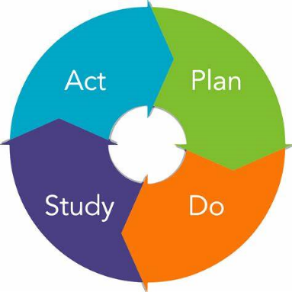



Strengthened Aged Care Quality Standards

Standard 3 - Personal Care and Clinical Care
Standard 1 - Consumer Dignity and Choice
Part 2 b) of this standard asks the RACH to support consumers to exercise choice and independence about their care and services.
The MyMedicare and General Practice in Aged Care Incentive program provides an avenue for consumers, to choose their preferred General Practice and nominate a Responsible Provider who is usually also their preferred GP.
Under this standard the RACH is to undertake initial and ongoing assessment and planning for care and services in partnership with the consumer. Assessment and planning focuses on optimising health and well-being in accordance with the consumer’s needs, goals and preferences.
The General Practice in Aged Care Incentive program enables RACH staff and patient’s general practitioner/ other care providers (NP, allied health practice nurse, Aboriginal and/or Torres Strait Islander Health Worker) to contribute to care planning for the resident. By planning regular visits as well as care planning activities with and for the resident it allows for a proactive approach to healthcare and management of any ongoing health concerns, care needs and chronic conditions.
Standard 2 - Assessment and Planning
This is the main standard that MyMedicare and General Practice in Aged Care Incentive supports. The expectation of this standard is that the RACH delivers safe and effective personal care, clinical care, or both personal care and clinical care, in accordance with the consumer’s needs, goals and preferences to optimise health and well-being.
Under Standard 3, the RACH is expected to documented risk assessments and care and services plans for each consumer and evidence that the organisation delivers personal and clinical care in line with these assessments and care and services plans General Practice in Aged Care Incentive supports the resident’s GP and other care providers to have input into the resident’s care planning needs. It also allows for referrals to be made to other care providers such as allied health and specialist based on medical assessment of the client and care planning needs.

